Make creative landing page report by

Leyan Monther Burait

📧: [lyanbyrat53@gmail.com](mailto:lyanbyrat53@gmail.com)

[layanbuirat (Leyan Buirat) (github.com)](https://github.com/layanbuirat)

Contents

Object: 4

The first step: 5

The second step: header of landing page 6

Min-higth 100vh : 8

Then the header css design 9

To put all next each other use display flex 9

Without line under word in navbar 10

Use     margin: 0 10px ; to do space between li in the navbar 10

The finally html div of header 10

Now will do div of content 11

Parent class content 12

Important note of css used to content div 12

To do text 13

The header (h2 ) .content.text h2 14

Paragraph in text : .content.text p{} 15

Link a of content text : .content. text a{} 15

Without line under word use     text-decoration: none; 15

To padding the limited space use : paddind: 8px 20px; 15

To do radius of button use :     border-radius: 20px; 15

Edit the image 16

But there are problem as shown bellow 16

All code of content index.html 18

So now all css code of content class 19

Now will do the icon of all image 20

Now will use absolute of icon div 20

The finally result 25

# Table of figure

Figure 1:red phone 4

Figure 2: blue phone 4

Figure 3: all files 5

Figure 4: connect with css & javascraipt 5

Figure 5: class of container 6

Figure 6: header 6

Figure 7: structure of navbar 7

Figure 8result after use min-hight:100vh 8

Figure 9when use display: flex 9

Figure 10use justify content : space between 9

Figure 11result of use space between 9

Figure 12: ul li a{} 10

Figure 13: resalt after do that 10

Figure 14: result after use margin 10

Figure 15: code of header in index.html 10

Figure 16: finally code in css of header 11

Figure 17: div text 11

Figure 18:div of image 11

Figure 19: parent class called content 12

Figure 20content class 12

Figure 21: result after do css of content parent class 13

Figure 22the text before 13

Figure 23: width of <p> text div 13

Figure 24: result after use width 14

Figure 25: result after edit the h2 14

Figure 26: result after edit the link 16

Figure 27: overflow: hidden; & the result of it after use 17

Figure 28: code of css content div 19

# Object:

Do web as shown bellow & the background & image of phone change when click to small image

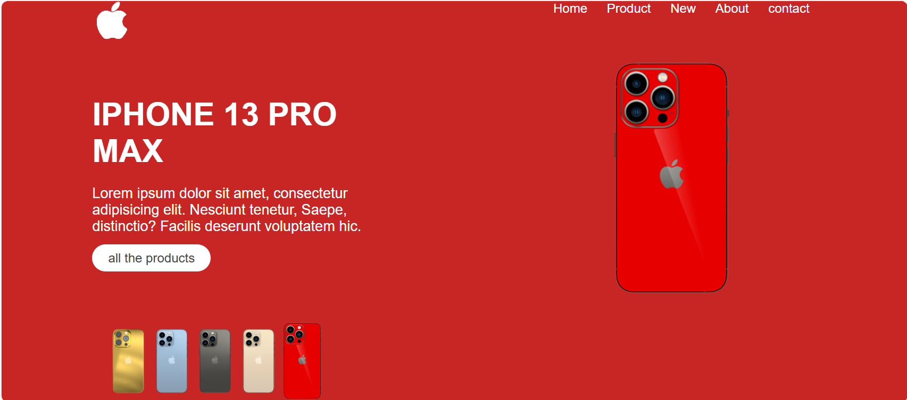

Figure 1:red phone

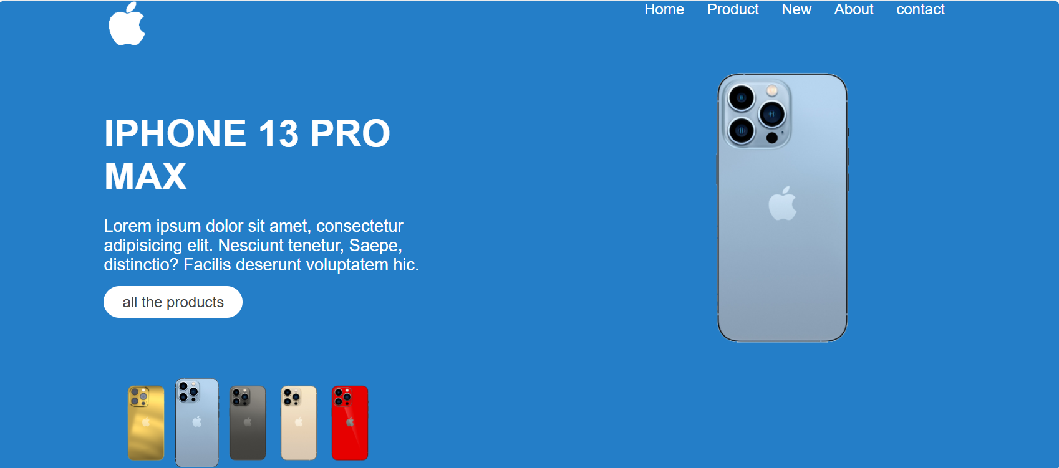

Figure 2: blue phone

# The first step:

Create folder of your project have the fellow files: index.html , style.css, main.js & image file as shown bellow:

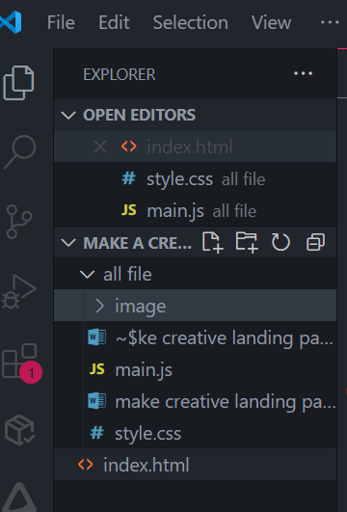

Figure 3: all files

Connect html file with style.css & Javascript file :main.js

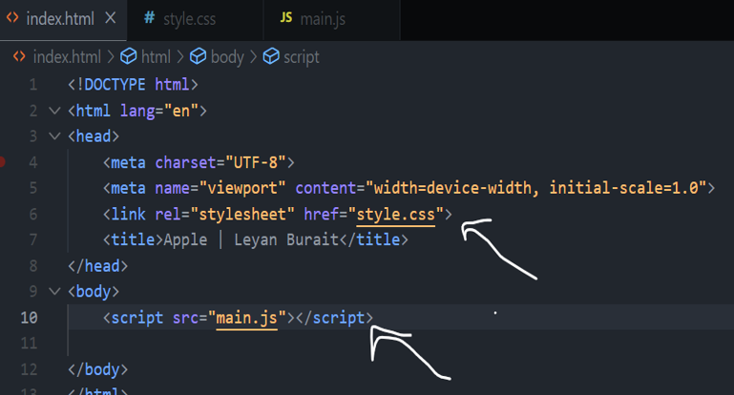

Figure 4: connect with css & javascraipt

Then make div of class container will have all div of your project

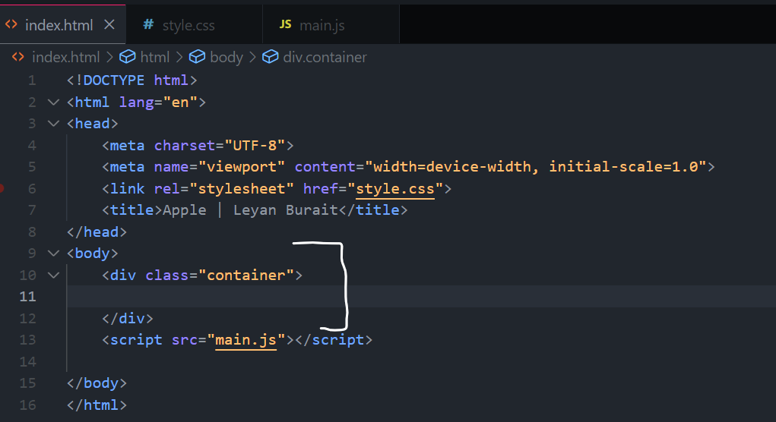

Figure 5: class of container

Download all image in to image 📂

# The second step: header of landing page



Figure 6: header

The header is contain of logo & navbar

1. Make div of header

 <div class="header">

        </div>

1. Do logo in link as

 <a href="#">img.logo</a>

Then

            <a href="#"><img src="./all file/image/logo.png" alt="there is some problem" class="logo"></a>

3-create structure of navbar as you shown bellow:

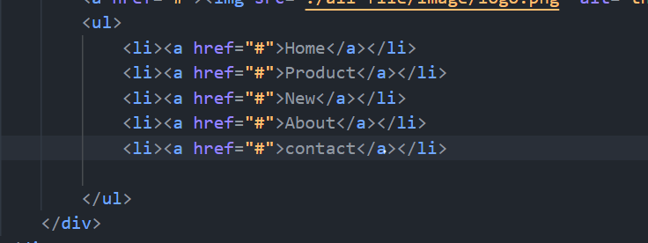

Figure 7: structure of navbar

The logo do not appear because the background is weight

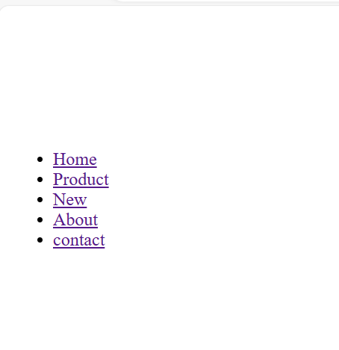

In css do the bellow

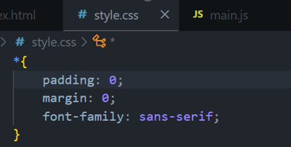

# Min-higth 100vh :

لتغطية الشاشة بالكامل

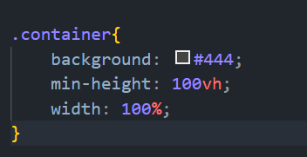

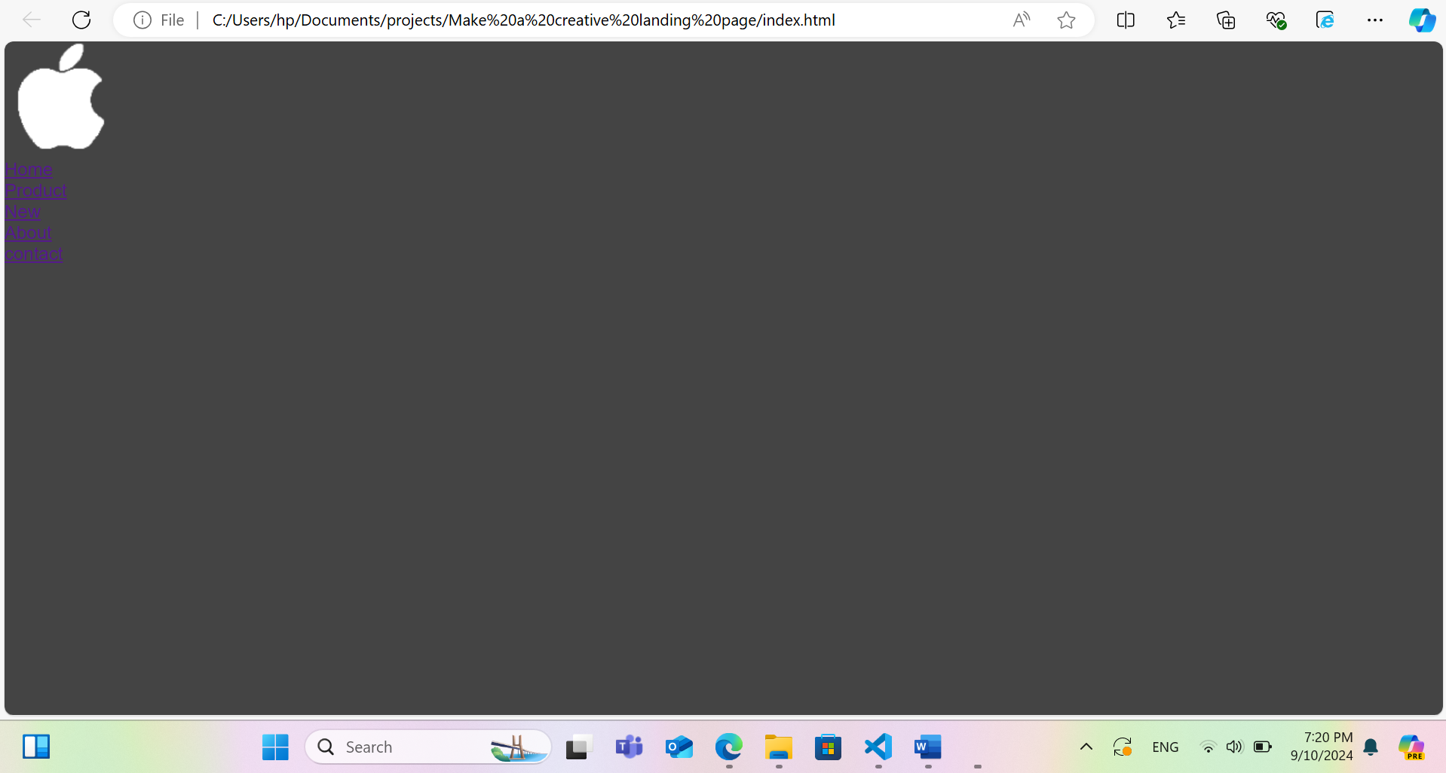

Figure 8result after use min-hight:100vh

# Then the header css design

## To put all next each other use display flex



Figure 9when use display: flex

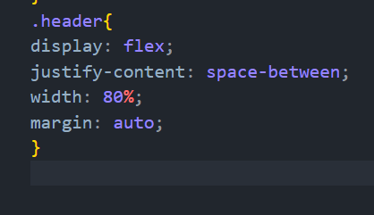

Figure 10use justify content : space between

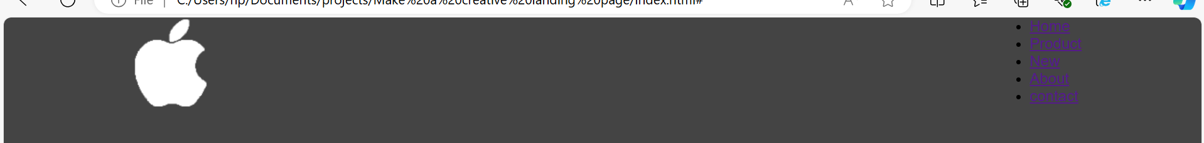

Figure 11result of use space between

To became list item next to each other as shown



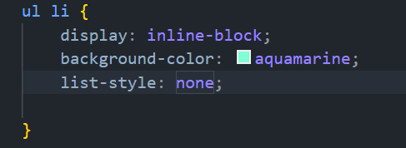

# Without line under word in navbar

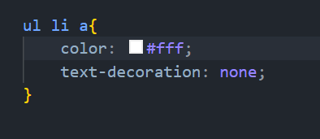

Figure 12: ul li a{}



Figure 13: resalt after do that

# Use     margin: 0 10px ; to do space between li in the navbar



Figure 14: result after use margin

# The finally html div of header

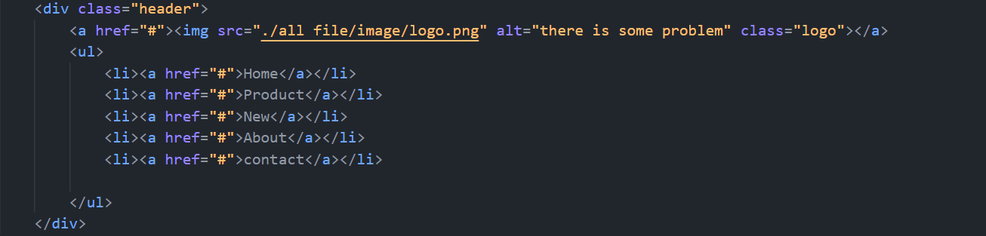

Figure 15: code of header in index.html

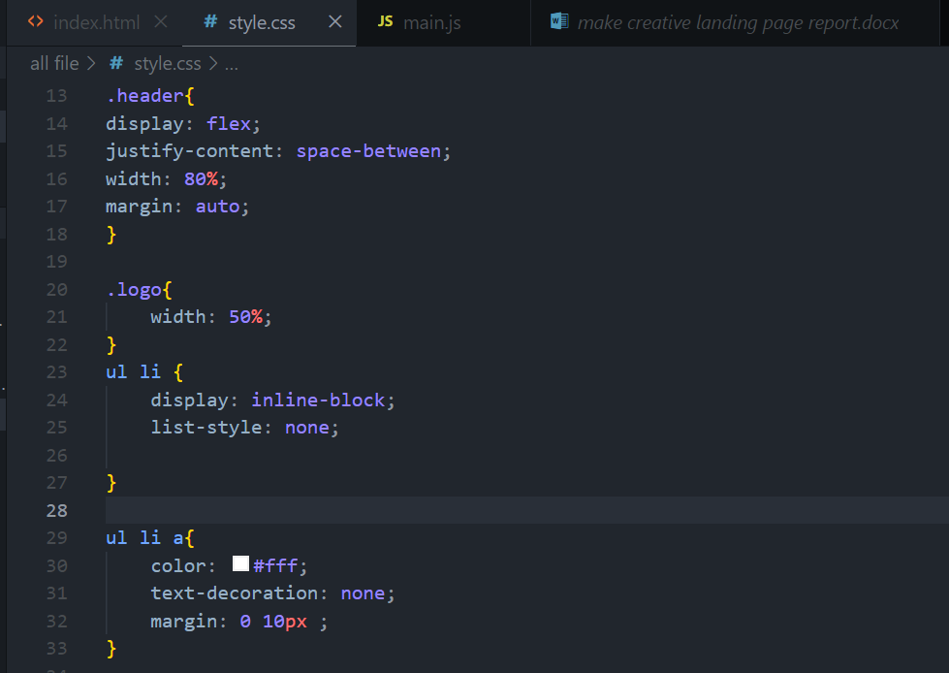

Figure 16: finally code in css of header

# Now will do div of content

Div of text & div of image then put it all in div of class called : content (parent classs)

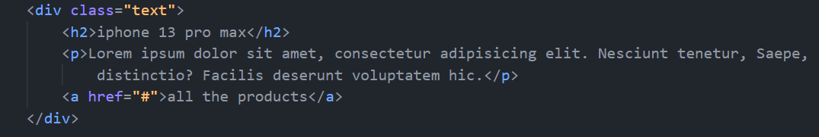

Figure 17: div text

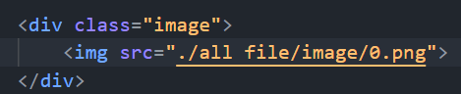

Figure 18:div of image

# Parent class content

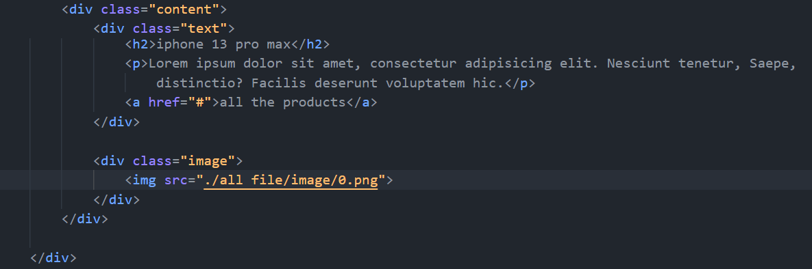

Figure 19: parent class called content

# Important note of css used to content div

Next to each other use : display: flex;

To do space between two div give the parents class : justify_content: space between;

To put all in the same line use:     align-items: center;

To do space double side of parent div use : margin :auto;

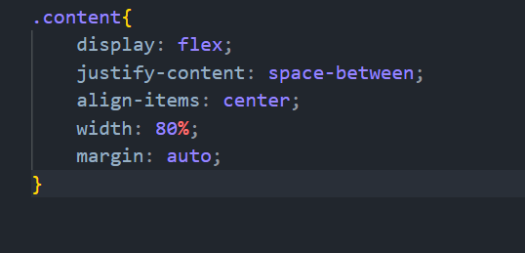

Figure 20content class

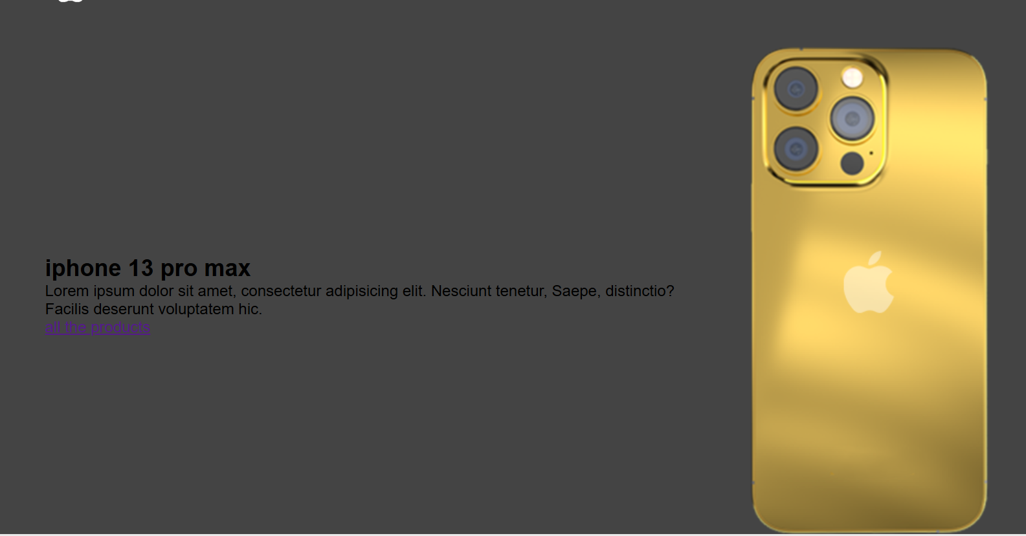

Figure 21: result after do css of content parent class

# To do text

Before as shown bellow

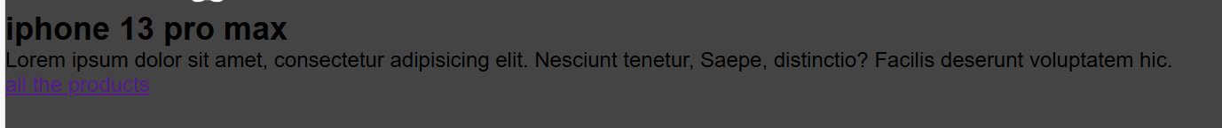

Figure 22the text before

Then after do bellow proprieties’ the result as shown bellow

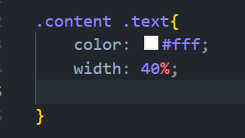

Figure 23: width of <p> text div

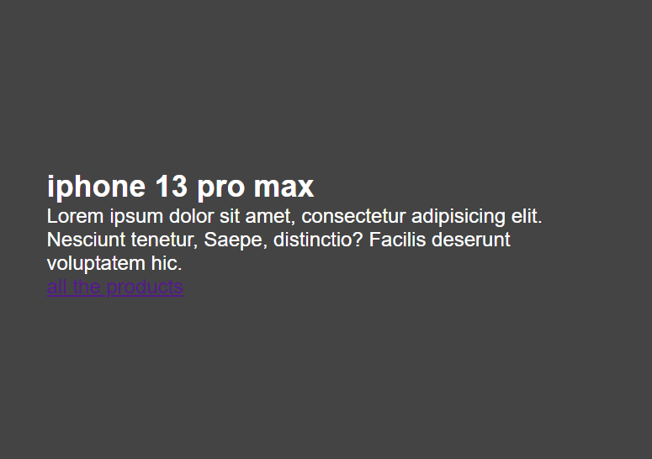

Figure 24: result after use width

# The header (h2 ) .content.text h2

Will use

 font-size: 40px; to change the size of font

text-transform: uppercase; to do h2 all litter in upper case

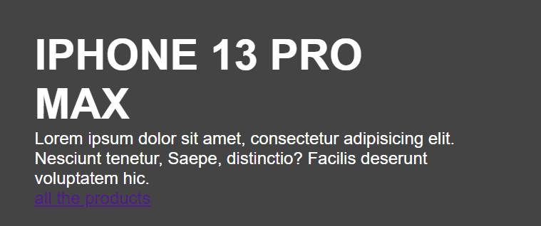

Figure 25: result after edit the h2

# Paragraph in text : .content.text p{}

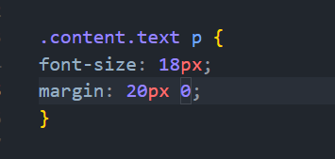

# Link a of content text : .content. text a{}

## Without line under word use     text-decoration: none;

## To padding the limited space use : paddind: 8px 20px;

## To do radius of button use :     border-radius: 20px;

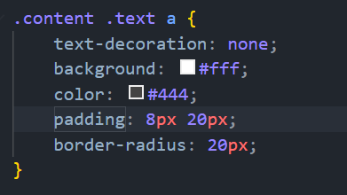

The result after do that must be as shown bellow



Figure 26: result after edit the link

# Edit the image

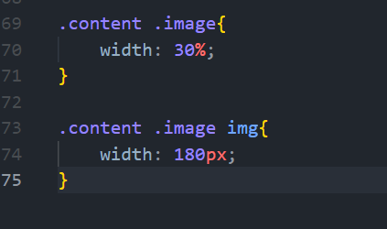

# But there are problem as shown bellow

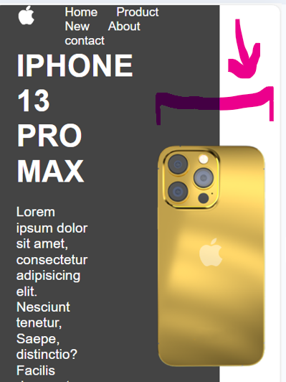

To solve this

Go to the parent container then use     overflow: hidden; as shown bellow

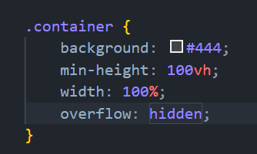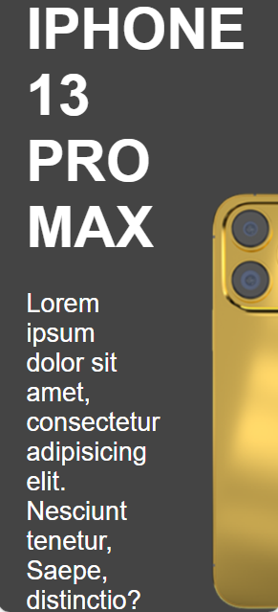

Figure 27: overflow: hidden; & the result of it after use

# All code of content index.html

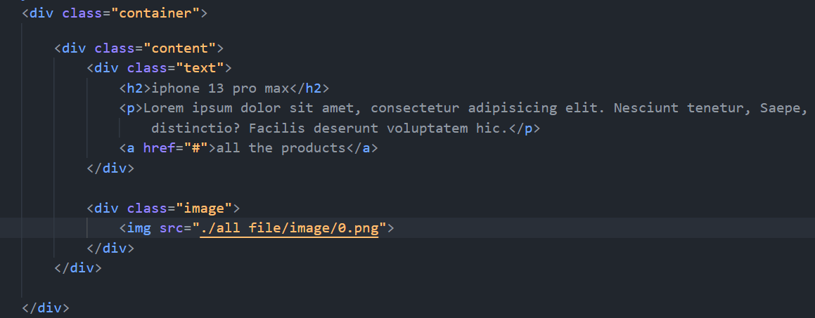

# So now all css code of content class

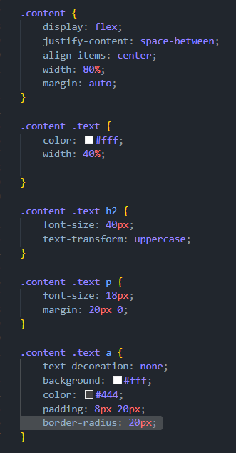

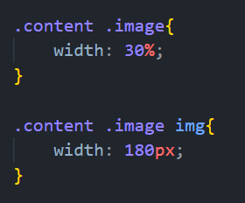

Figure 28: code of css content div

# Now will do the icon of all image

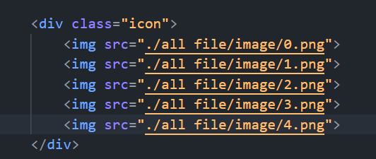

# Now will use absolute of icon div

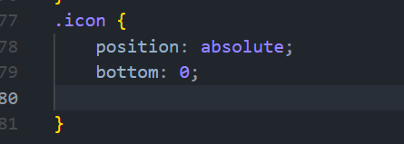

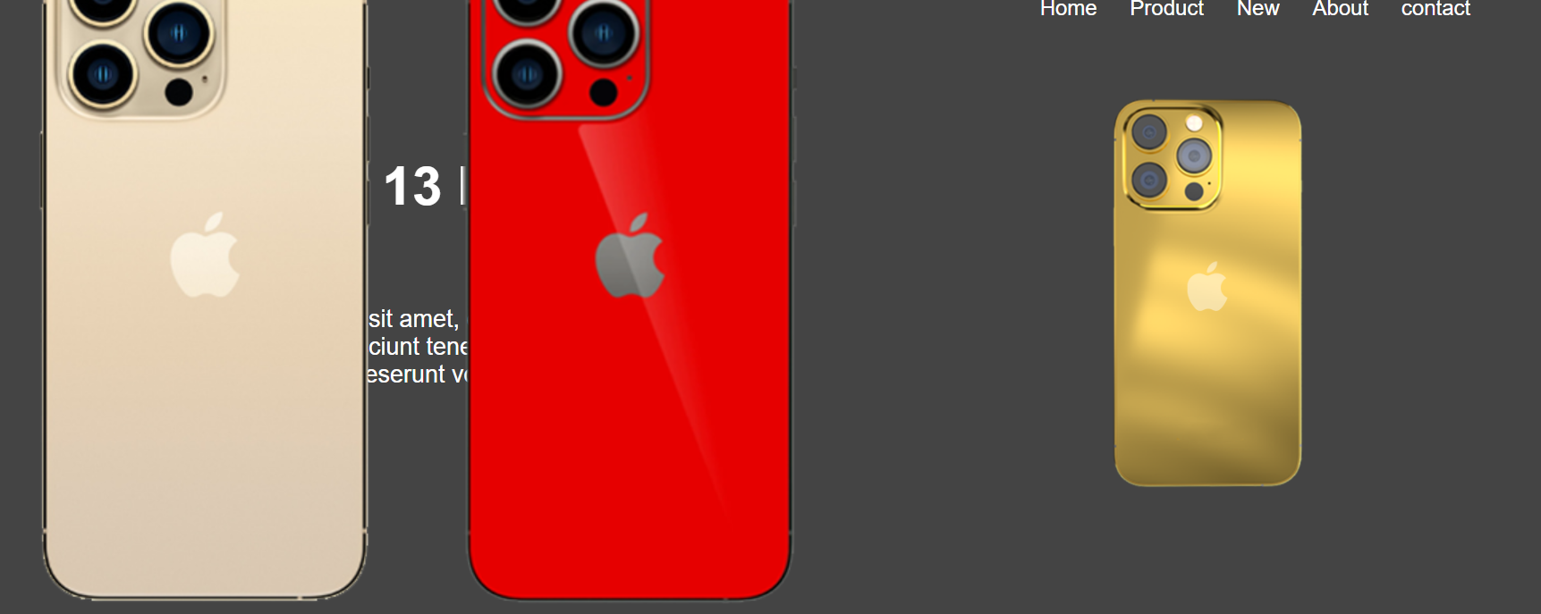

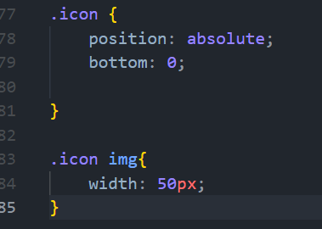

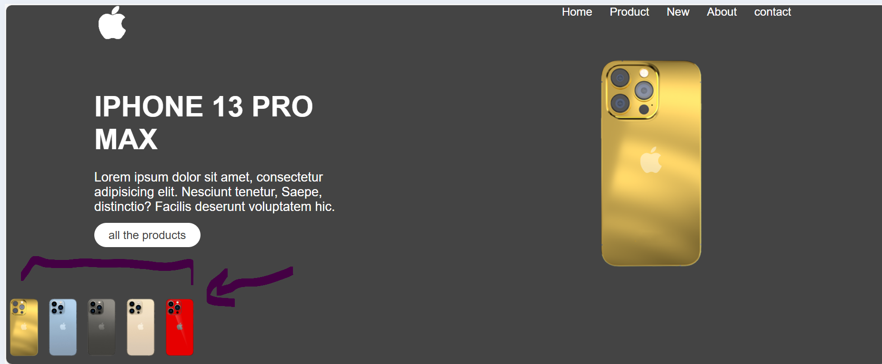

To put it in center use

bottom: 20px; & transform: translateX(-50); in icon as shown bellow

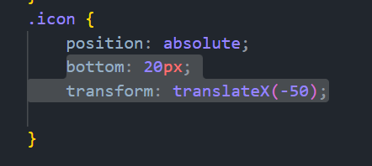

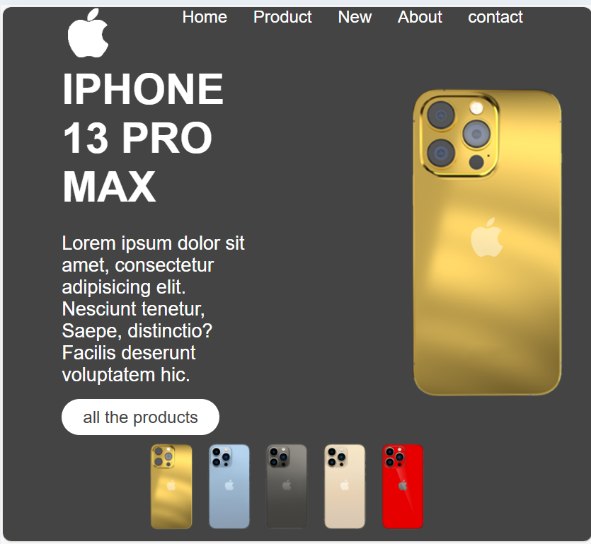

للتأخير بمقدار نص ثانية

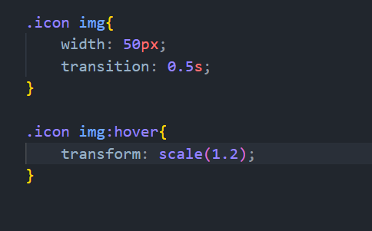

هسا قبل لما اكبس عليهم ما بتأثر ولا بضغط ع الصور بس اذا استخدمت اللي فوق بتأثر الصور لما اكبس علي

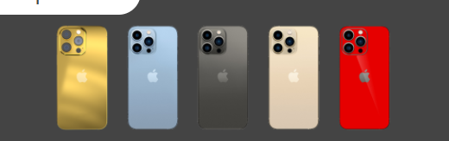

بعد الاستخدام لما ضغطت على الذهبي مثلا تأثر

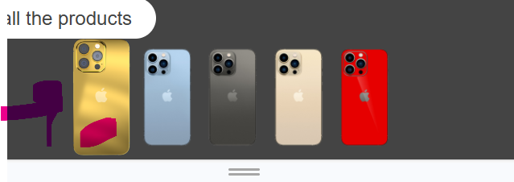

وممكن استخدم pointer

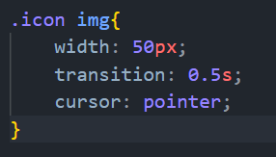

________________now will start Javascript_______________________

1_ go to content then the div of img give class = ‘img’

Before

                <img src="./all file/image/0.png">

After

                <img class="img" src="./all file/image/0.png">

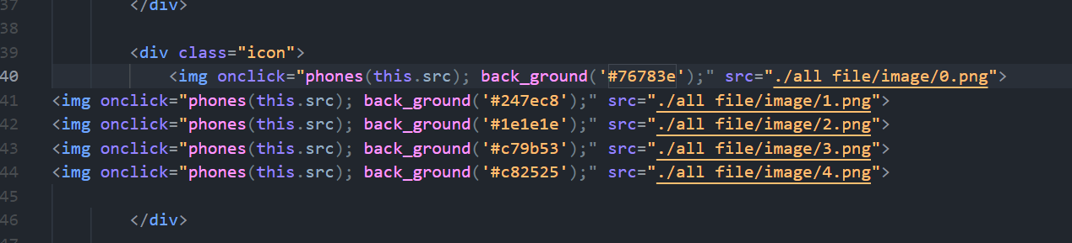

In main.js

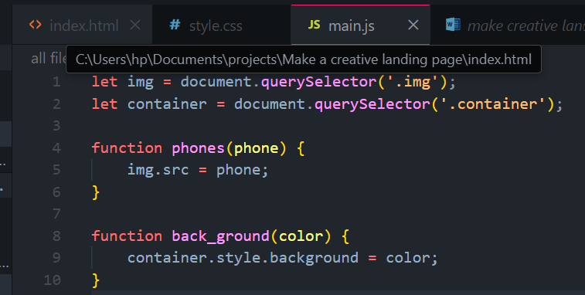

# The finally result

